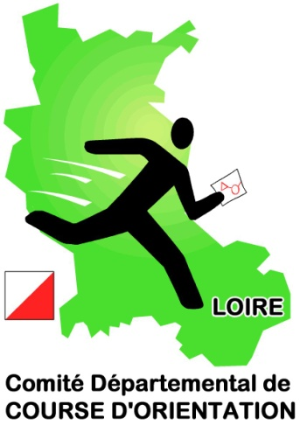
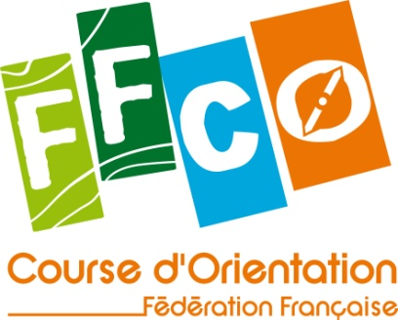
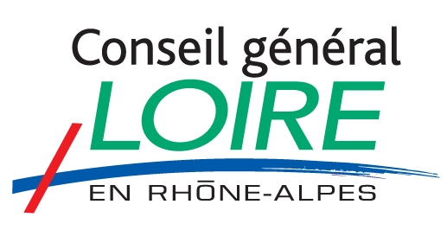

JUNIOR EUROPEAN CUP 2013 – FRANCE

Invitation / Bulletin 1

Organiser : Comité Départemental de la Loire de course d’orientation
Website: http://cdcoloire.free.fr/
Email : cdcoloire@free.fr
Date: 4. – 6. October 2013
Venue : Saint Etienne – Mountain « Le Pîlat »

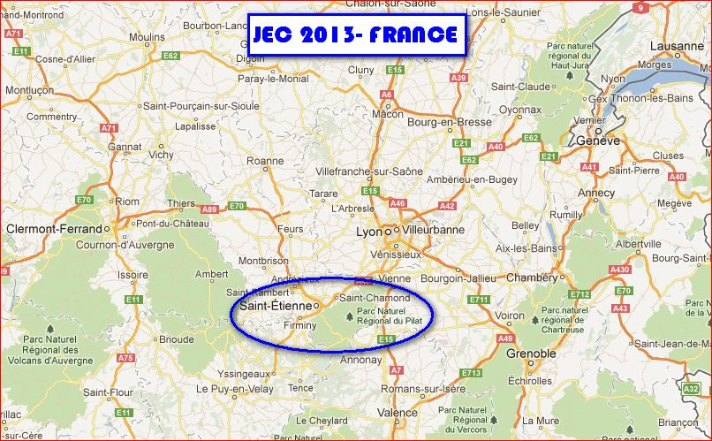

Programme Friday 04.10.13 sprint (PM)
Saturday 05.10.13 relay
Sunday 06.10.13 long distance

There are public races in parallel to JEC 2013 on Saturday and Sunday.

Participants The Junior European Cup is open to national teams for competitors no older than 20 years of age on 31.12.2013. Maximum 4 staffs per nation.

Classes Sprint/Long Distance races: W18, M18, W20, M20
Relay: Men/Women (3 runners per relay)

A maximum of 6 runners per national team in each class

For the relay: As many teams of three as can be made up from your entry.

Terrain description Sprint: the area is not fixed but two kinds of area had been targed: mix of urban terrain, forest and open land or totally urban (news maps, for the both choices)

Relay & Long: typical “Pîlat” terrains. Continental terrain with some parts rich of vegetations details. Coniferous forest mostly, runnibilty and visibility mostly good.

Embargoed areas Sprint: Saint Etienne center city or Le Bessat.
Relay & Long: existing map “La Jasserie” 1998 or “Les 3 Evèques” 1993

As of now these areas are embargoed for orienteering activities.

Electronic punching SportIdent system will be used in all JEC 2013 races. SI cards can be hired system on request.

Costs The accommodation is not yet determined and, hence, the final costs
will be announced in Bulletin 2.

Entries In order to reserve accommodations, indicative entries are to be
receives as soon as possible. Please use the info-email address above.

Training Maps for your own training are available before and after JEC 2013.

Transports Teams have to organise their own travel to the region and during the
event. Nearest Airport is Lyon (1h15)
Alternatives: Genève (SUI – 2h45) or Marseille (3h30)

For answers to any questions at this stage please email: cdcoloire@free.fr

